

This is an open access article published under an ACS AuthorChoice License, which permits copying and redistribution of the article or any adaptations for non-commercial purposes.

[pubs.acs.org/jchemeduc](http://pubs.acs.org/jchemeduc)

Article

Beyond “Inert” Ideas to Teaching General Chemistry from Rich Contexts: Visualizing the Chemistry of Climate Change (VC3)

Peter G. Mahaﬀy,*,[† Thomas A. Holme,‡ Leah Martin-Visscher,[†](#_bookmark0) Brian E. Martin,[§](#_bookmark0) Ashley Versprille,[∥](#_bookmark0) Mary Kirchhoﬀ,[⊥](#_bookmark0) Lallie McKenzie,[#](#_bookmark0) and Marcy Towns[∥](#_bookmark0)](#_bookmark0)

†Department of Chemistry and the King’s Centre for Visualization in Science, The King’s University, Edmonton, Alberta T6B2H3, Canada

‡Department of Chemistry, Iowa State University, Ames, Iowa 50011, United States

§Department of Physics and the King’s Centre for Visualization in Science, The King’s University, Edmonton, Alberta T6B2H3, Canada

∥Department of Chemistry, Purdue University, West Lafayette, Indiana 47907, United States

⊥Education Division, American Chemical Society, Washington, D.C. 20036, United States

#Chem11, Eugene, Oregon 97403, United States

*S *Supporting Information*

ABSTRACT: As one approach to moving beyond trans- mitting “inert” ideas to chemistry students, we use the term *“teaching from rich contexts”* to describe implementations of case studies or context-based learning based on systems thinking that provide deep and rich opportunities for learning crosscutting concepts through contexts. This approach nurtures the use of higher-order cognitive skills to connect concepts and apply the knowledge gained to new contexts. We describe the approach used to design a set of resources that model how rich contexts can be used to facilitate learning of general chemistry topics. The Visualizing the Chemistry of Climate Change (VC3) initiative provides an exemplar for introducing students in general chemistry courses to a set of

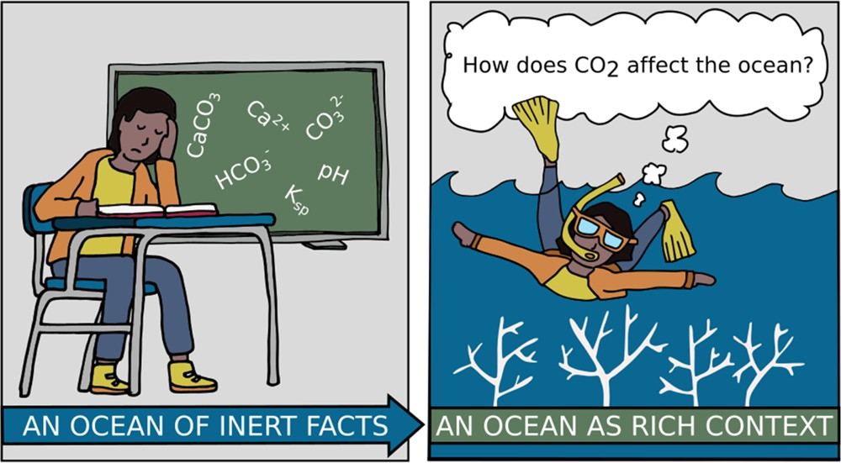

core chemistry concepts, while infusing rich contexts drawn from sustainability science literacy. Climate change, one of the deﬁning sustainability challenges of our century, with deep and broad connections to chemistry curriculum and crosscutting concepts, was selected as a rich context to introduce four topics (isotopes, acids−bases, gases, and thermochemistry) into undergraduate general chemistry courses. The creation and assessment of VC3 resources for general chemistry was implemented in seven steps: (i) mapping the correlation between climate literacy principles and core ﬁrst-year university chemistry content,

(ii) documenting underlying science conceptions, (iii) developing an inventory of chemistry concepts related to climate change and validating instruments that make use of the inventory to assess understanding, (iv) articulating learning outcomes for each topic, (v) developing and testing peer-reviewed interactive digital learning objects related to climate literacy principles with particular relevance to undergraduate chemistry, (vi) piloting the materials with ﬁrst-year students and measuring the change in student understanding of both chemistry and climate science concepts, and (vii) disseminating the interactive resources for use by chemistry educators and students. A novel feature of the approach was to design resources (step v) based on tripartite sets of learning outcomes (step iv) for each chemistry and climate concept, with each knowledge outcome accompanied by an outcome describing the evidential basis for that knowledge, and a third outcome highlighting the relevance of that knowledge for students.

KEYWORDS: *Curriculum, First-Year Undergraduate/General, Interdisciplinary/Multidisciplinary, Internet/Web-Based Learning, Acids/Bases, Atmospheric Chemistry, Isotopes, Gases, Thermodynamics, Misconceptions/Discrepant Events*

* A CHEMISTRY EDUCATION CHALLENGE: BEYOND

“INERT” IDEAS TO MEANINGFUL AND RELEVANT

LEARNING CONNECTED TO IMPORTANT CONTEXTS

*Normally we teach out of context. The biology teacher’s teaching here, the mathematics teacher there, the English teacher over here...and when it’s time to synthesize, guess what? We aren’t there.*

© 2017 American Chemical Society and

This quote from Fred Johnson1 (National Science Teachers Association past-president), discussing the STEM challenges that led to the reforms in the U.S. K−12 Next Generation Science

Standards,2 resonates with a century-old critique by Alfred North

Received: December 23, 2016

Revised: May 17, 2017

Published: July 5, 2017

Division of Chemical Education, Inc. 1027 DOI: [10.1021/acs.jchemed.6b01009](http://dx.doi.org/10.1021/acs.jchemed.6b01009)

Downloaded via INDIANA UNIV PURDUE UNIV AT IN on January 24, 2024 at 16:04:07 (UTC). See https://pubs.acs.org/sharingguidelines for options on how to legitimately share published articles.

Whitehead. In his 1916 address to the Mathematical Association of England, Whitehead3 critiqued a central characteristic of schools, that they were radically infected with “inert” ideas, ideas that “are merely received into the mind without being utilized, or tested, or thrown into fresh combinations”. He called for “eradicating the fatal disconnection of subjects that kills the vitality of modern curriculum”, and connecting learning to life. We should prove the ideas that are set out, Whitehead said, that is, “prove their worth and value to students”, and endeavor “not to use propositions in isolation”. “The problem of education”, he concluded, “is to make the pupil see the wood by means of the trees”.

Chemistry educators have documented the compelling nature of the challenges facing chemistry education, many of which have parallels with Whitehead’s challenge to see the woods and avoid being lost in the trees. Students experience clusters of isolated facts in indigestible bundles, theoretical ideas that are unconnected to their lives, diﬃculty in transferring learning to problems presented in new ways, and an overemphasis on preparation for further study in chemistry rather than developing the scientiﬁc literacy needed to function as future scientists,

engineers, and informed citizens.4−9

General chemistry courses are a particularly important target

for reform, as they are gateways for entry to a broad range of careers in science, health, environment, and engineering. The stakes for “getting it right” in general chemistry are raised even further when considering that, for many careers in science, students will experience either no additional chemistry, or per- haps a course in organic chemistry, in their academic program. A recent editorial in this *Journal*7 calls for moving the under- graduate general chemistry curriculum from a “disjointed trot through a host of unrelated topics” to an innovative curriculum that includes a robust understanding of fundamental overarching chemistry principles and themes, with assessable learning outcomes.

While general chemistry instruction has remained relatively static for four or ﬁve decades,10 the world that graduates enter is increasingly characterized by substantial and rapid change. Multiple unfolding global challenges related to environment, population, health, water, and energy are increasingly visible, and the molecular sciences are acknowledged as having a central role to play in working toward solutions.11,12 General chemistry students, the vast majority of whom will not major in chemistry, need to understand the crosscutting relevance of chemistry con- cepts to knowledge gained in other courses and to their ability to function as well-educated citizens in a world of complexity and change. A reorientation of chemistry teaching and learning has been called for in a recent commentary in *Nature Chemistry*, suggesting that chemistry must be taught in contexts that are relevant to society and contribute to meeting global challenges, and that are based on a systems perspective including physical, biological, environmental, and other systems.13 To equip an informed citizenry for responsible decision-making based on chemical thinking is a grand challenge that requires “the development of educational resources that provide clear examples of how to best integrate authentic chemistry practices with core chemical ideas”.14 While educational resources, such as the American Chemical Society’s *Chemistry in Context* (ninth edition forthcoming) have been developed for post- secondary nonscience majors, few examples are available of widely successful implementations for science majors. The approach and resources described here provide one clear example of educational

resources for general chemistry based on a systems perspective, to help meet this grand challenge.

# TEACHING FROM RICH CONTEXTS: THEORETICAL UNDERPINNINGS, EMPIRICAL EVIDENCE, AND LIMITATIONS

■

Various permutations of context-based learning, along with related approaches such as case-based learning and problem- based learning, have been employed in secondary and post- secondary education in North America, Europe, and elsewhere, as strategies to address the pedagogical challenge identiﬁed above and to model science education’s potential to equip students for the increasing complexity and uncertainty of our world.15 Context-based learning uses context and applications of science as the starting point for the development of scientiﬁc ideas,16 rather than comprehensively covering concepts and then including one or more interesting applications. Building on its Latin roots (“contextus”: coherence, connection, relationship), the term context is used here to describe “coherent structural meaning”5 (Whitehead’s “seeing the wood”) for introducing chemistry facts that students learn.

Theoretical frameworks that have guided context-based learning15,16 include conceptual change frameworks, personal constructivism,17,18 and the learning theory of situated cognition, which synthesizes elements of behaviorist and cognitive theoretical perspectives. Context-based approaches recognize that all learning is situated in physical, cultural, and social con- texts.6,19,20 Content that is introduced through contexts may be anchored more ﬁrmly in memory,21 giving learners greater ability to apply concepts to new contexts. This is less likely to be the case for knowledge that is stored in memory without connections to real-life contexts.21 Our implementation of teaching from rich contexts is also inﬂuenced by prior articulation of the meaning of “authentic” practices,6,22,23 “meaningful” science learning,24 and eﬀective approaches for infusing nature of science considerations25 into the teaching and learning of science. Theories of motivation and interest development support the claim that emotional and aﬀective aspects play an important role in the development of positive attitudes toward

learning and in the learning of chemistry.26−30

As discussed below, one novel feature of our approach to

teaching from rich contexts is to design instructional materials and assessments based on tripartite learning outcomes, in which each knowledge outcome is accompanied by an outcome describing the evidential basis for that knowledge, and a third outcome highlighting the relevance of that knowledge for students. Other educational researchers, some of whom were directly responding to Whitehead’s critique of “inert” education, have also developed approaches to move beyond the formulation of content learning outcomes in designing curriculum. Mason and Spence31 have surveyed the literature on forms of knowing in education, and include a critique of “knowing about” subject matter that narrowly focuses learning on knowledge that is easy to teach and test. Students may become very accomplished at passing examinations, but they have real diﬃculty using the cognitive tools of their domain to apply what they have been taught to more general or less familiar problems or new contexts. They suggest an additional form of knowing, “knowing to”, as a goal for active knowledge that moves beyond “inert” ideas and integrates tools into the functioning of students in their worlds. Recent reviews of empirical data on the eﬀectiveness of context-based approaches have focused mostly on the more frequent implementations at the secondary level, with much less

work to date on implementing and assessing initiatives at the postsecondary level.6,15 Research demonstrates that context- based learning results in positive eﬀects on student attitude and the development of transferrable and intellectual skills.21,32 Studies suggest comparable or better results on student learning, but few well-designed studies using contemporary learning models have been carried out, especially at the postsecondary level.6 Potential challenges with the implementation of context- based approaches have also been identiﬁed, including the need to develop strategies for both students and teachers to approach less structured problems that are conceptually more complex,15 although this challenge is not unique to context-based learning. A limitation to the wider acceptance and application of context- based learning is the perception that important domain content may be “left out” when introducing topics through rich contexts. Further research to assess cognitive and aﬀective learning gains from context-based approaches and to measure the extent to which context-based approaches facilitate the transfer of learning of chemical concepts to new contexts, relative to traditional approaches, may help to inform this discussion. Professional development for chemistry educators on systems approaches and the nature of the particular rich contexts that are used will be needed to overcome concerns about faculty reluctance to use unfamiliar contexts.

■

# CLIMATE SCIENCE AS A RICH CONTEXT FOR TEACHING CHEMISTRY

In selecting a rich context as a proof-of-concept exemplar for implementation with postsecondary general chemistry students, climate science was chosen for several reasons. The ﬁrst is global recognition of the importance of understanding and addressing climate change. Climate change has been identiﬁed as one of only two core planetary boundaries, which has the potential on its own to drive the earth system into a new state, should the boundary be substantially and persistently exceeded.33,34 Economists, as well as scientists, are concerned, as 6.0 °C of warming would represent a loss of 30% of the current value of the world’s manageable ﬁnancial assets.35 Unmitigated climate change is estimated to reduce the income of an average person on earth by 23% by 2100 and by 75% in the poorest 40% of countries.36 And public policy experts project substantially ampliﬁed rates of human conﬂict in the coming decades due to changing local climates.37

Recognition of the planet-scale inﬂuence of human beings has

led to a recommendation by the Anthropocene Working Group to the international geological science community that our planet has left the Holocene and entered the Anthropocene Epoch38 on the geologic time scale. The case for having entered the Anthropocene (Greek “anthropo-”, human; and “-cene”, new) Epoch is based on quantitative analysis of rapidly escalating changes to parameters (including climate change) that deﬁne our capacity to live safely within the boundaries of our planetary life support systems. Since much of the data being assessed to evaluate the human footprint is based on measurements and insights from chemistry at its interfaces with earth, atmospheric, and marine sciences, a compelling case can be made that chemistry educators should attend to these crosscutting contexts in curricula.39

Universities have been charged with taking leadership in addressing the issue of restabilizing earth’s climate, which has been identiﬁed as a deﬁning challenge of the 21st century.40 Yet this task is enormously diﬃcult. Climate science is complex and crosscutting, and making sense of climate change requires a

systems framework41 that draws on insights from chemistry, physics, biology, and environmental, atmospheric, and earth sciences. Perhaps due in part both to its complexity and inter-

disciplinary nature, climate science has been slow to be incor- porated into science curricula at either the K−12 or post- secondary levels in education standards or science education curriculum,42 although several dimensions of climate science are now found in the U.S. Next Generation Science Standards.43

Pervasive and robust misconceptions about climate have been documented, some of which have at their heart fundamental (mis)understandings of the molecular world.44,45

While the complexity of climate science as a rich context for teaching and learning of chemistry poses challenges, it also presents unique opportunities.46 Understanding complex systems is fundamental to developing an authentic under- standing of science, and understanding of science is needed to guide responsible action. Climate change represents a classic complex system. “*The spatial scale is global; the time scale dwarfs normal human concerns; and the dynamics of the climate are exquisitely complex and imperfectly understood.*”47 The complexity of systems such as our climate makes them diﬃcult to understand because they are composed of multiple interrelated levels that interact in dynamic ways.48

Many of the concepts underlying the science of climate change involve concepts for which learner conceptual understanding must result in the use of informed imagination to construct robust mental models. Consider the challenge for a ﬁrst-year student trying to imagine correctly how “greenhouse gases” function at the molecular-level as an anthropogenic driver for earth’s changing radiation balance. A robust mental model requires the synthesis of fundamental knowledge about the interaction of electromagnetic radiation with molecules, leading to the ability to picture interaction of trace amounts of colorless carbon dioxide with invisible infrared radiation. It further requires an understanding of how subsequent interactions of vibrationally excited carbon dioxide molecules with IR-inactive atmospheric nitrogen and oxygen gases ultimately lead to tro- pospheric warming.

Achieving climate literacy in the framework of complexity brings an opportunity for chemistry education to move beyond “inert” ideas to embrace pedagogies based on student conceptual understanding, to eﬀectively use interactive visualizations,49 and to explore teaching from rich contexts as a means to facilitate student engagement with and understanding of chemistry and interdisciplinary science concepts. The limited availability of context- and content-rich resources that are linked to curricular learning outcomes in introductory chemistry is a signiﬁcant barrier to more widespread adoption of new pedagogical approaches and provides one motivation for this project.

■

# VISUALIZING THE CHEMISTRY OF CLIMATE CHANGE

The process of developing resources used in the visualizing the chemistry of climate change (VC3) initiative provides an exemplar for introducing students in general chemistry courses to a set of core chemistry concepts, while infusing rich contexts drawn from a larger rich context: in this case, sustainability science literacy. The interactive web-based VC3 digital learning objects resources aim to (i) exemplify science education for sustainability, (ii) improve the understanding of climate change by both undergraduate students and faculty members, and

(iii) provide “best-practice” resources to support chemistry

instructors in adopting active-learning pedagogies that situate

cognition in authentic science practice and globally important contexts.

VC3: Approach and Methods

The process for designing and implementing resources for VC3 is described in Figure 1.

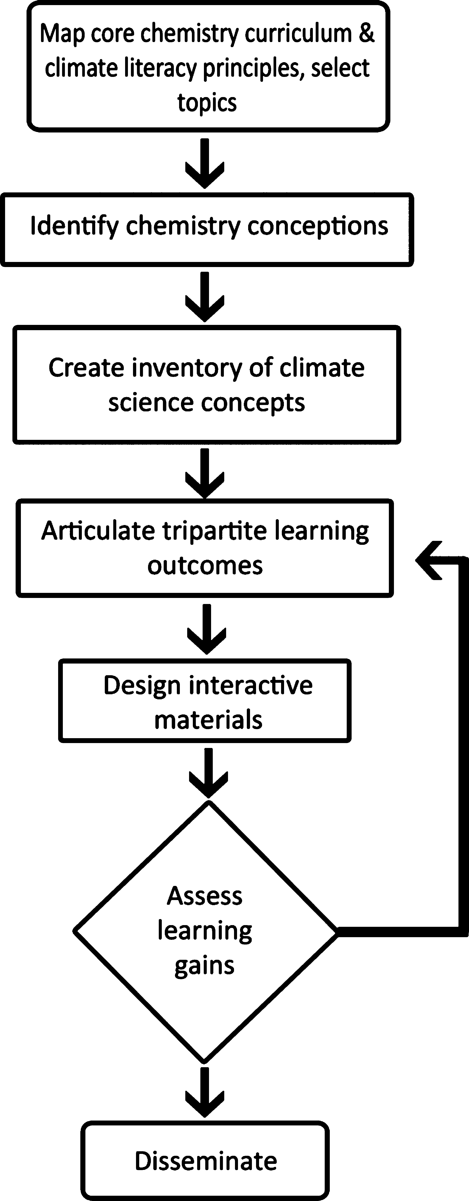

Figure 1. Process for creating and implementing VC3 resources to infuse climate literacy goals into the teaching of general chemistry.

Step 1. Map the Correlation between Core Chemistry Content and Climate Literacy Principles To Identify Topics for Introduction of Rich Contexts. Traditional core chemistry topics widely introduced in North American general chemistry courses were identiﬁed by surveying seven text-

books widely in use at the beginning of the study50−56 and

course outlines from representative universities and colleges.

A comprehensive climate literacy framework, Climate Liter- acyEssential Principles of Climate Science,57 was developed by the U.S. Climate Change Science Program (CCSP), which integrates federal research on climate and global change, as sponsored by 13 U.S. federal agencies. This framework provided an authoritative set of essential principles and scientiﬁc thinking skills thought to be required by a climate literate citizen. We then created a detailed interactive map (a representative portion of which is shown in Figure 2) to identify the coherence between the CCSP literacy principles and core general chemistry concepts.

The mapping exercise identiﬁed four chemistry topics as particularly suitable for development of climate-science-rich contexts to introduce general chemistry content:

* + Isotopes
  + Gases
  + Acid−base chemistry
  + Thermochemistry

Step 2. Identify Chemistry Alternative Conceptions for Each Topic. For each of the four key chemistry topics, the science education literature was surveyed to identify documented

student alternative conceptions,58−62 and this information, along with results from identiﬁed climate conceptions (step 3),

was used in writing learning outcomes and creating student resources.

Step 3. Identify Climate Alternative Conceptions for Each Topic. While researchers have identiﬁed concepts relating to climate, atmosphere, and fossil fuel use in geoscience contexts

that are commonly misunderstood,42 climate conceptions that are particularly relevant to the learning of chemistry had not been well-documented. Two initiatives were carried out to address this gap. First, an investigation of general chemistry students’ understanding of the chemistry underlying climate change was performed.63 Then a two-tiered climate science diagnostic instrument for use in general chemistry classes was developed and implemented at two institutions to measure student under- standing of climate change, the behavior of gases, and the mechanism of radiative forcing of gases. This instrument was developed across the life of the project and has been published in this *Journal* for use by the community.45

Step 4. Articulate Tripartite Learning Outcomes for

Each Key Idea. To give appropriate attention to both the nature of science considerations and the relevance of contexts to students and society in addition to content knowledge, tripartite learning outcomes were articulated for each chemistry and climate literacy content outcome. Each content knowledge outcome (“What do chemists know?”) was accompanied by an evidential outcome (“How do chemists know this?”), and a third relevance outcome (“Why should students care about this knowing?”). Each learning outcome was evaluated using a modiﬁed Bloom’s taxonomy,64 and most were accompanied by assessment questions, some of which formed the basis of pre- and post-test instruments that were used to assess learning gains (Table 1).

Step 5. Design a Suite of Interactive Electronic Learning Materials for Students. On the basis of the mapping of chemistry concepts to climate literacy principles and the analysis of alternative conceptions related to both chemistry and climate concepts, a suite of interactive electronic learning resources were created for students to guide them toward the attainment of the tripartite learning outcomes. At the beginning of each of the four modules (isotopes, gases, acids and bases, and thermochemistry), students are ﬁrst invited to engage with an overall concept question that integrates the climate context into the chemistry content area, followed by a set of key chemistry ideas, each of which also starts with a more speciﬁc concept question. In each key idea section, headers labeled “What do we know?” (knowledge outcome), “How do we know?” (evidential outcome), and “Why should we care?” (relevance outcome) are used to overtly focus student and instructor attention on the tripartite learning outcomes. Higher-order conceptual questions are included under the header “Question for Thought” and interactive feedback given to students with “Worked Examples”

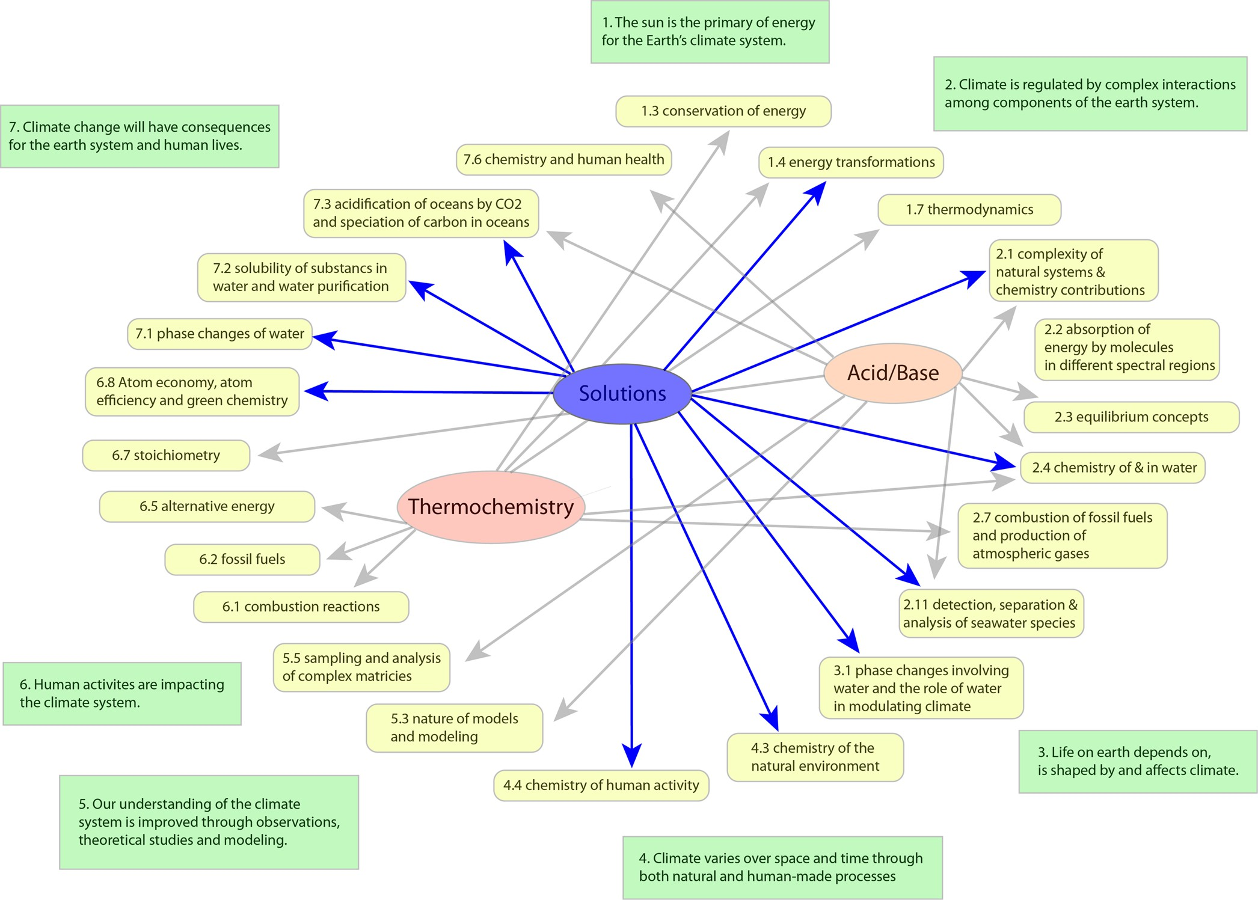

Figure 2. Small portion of the map showing the coherence between climate literacy principles and general chemistry topics. An interactive electronic version of the complete map is available as [Supporting Information](http://pubs.acs.org/doi/suppl/10.1021/acs.jchemed.6b01009/suppl_file/ed6b01009_si_001.zip): green boxes on the outside represent the essential principles of climate literacy, colored ovals in the middle are core chemistry concepts, and yellow rectangles connecting the two are chemistry key ideas that oﬀer potential starting points for infusing climate principles with chemistry content.

Table 1. Tripartite Learning Outcomes and an Assessment Question for a Key Chemistry Concept in the Isotopes Module

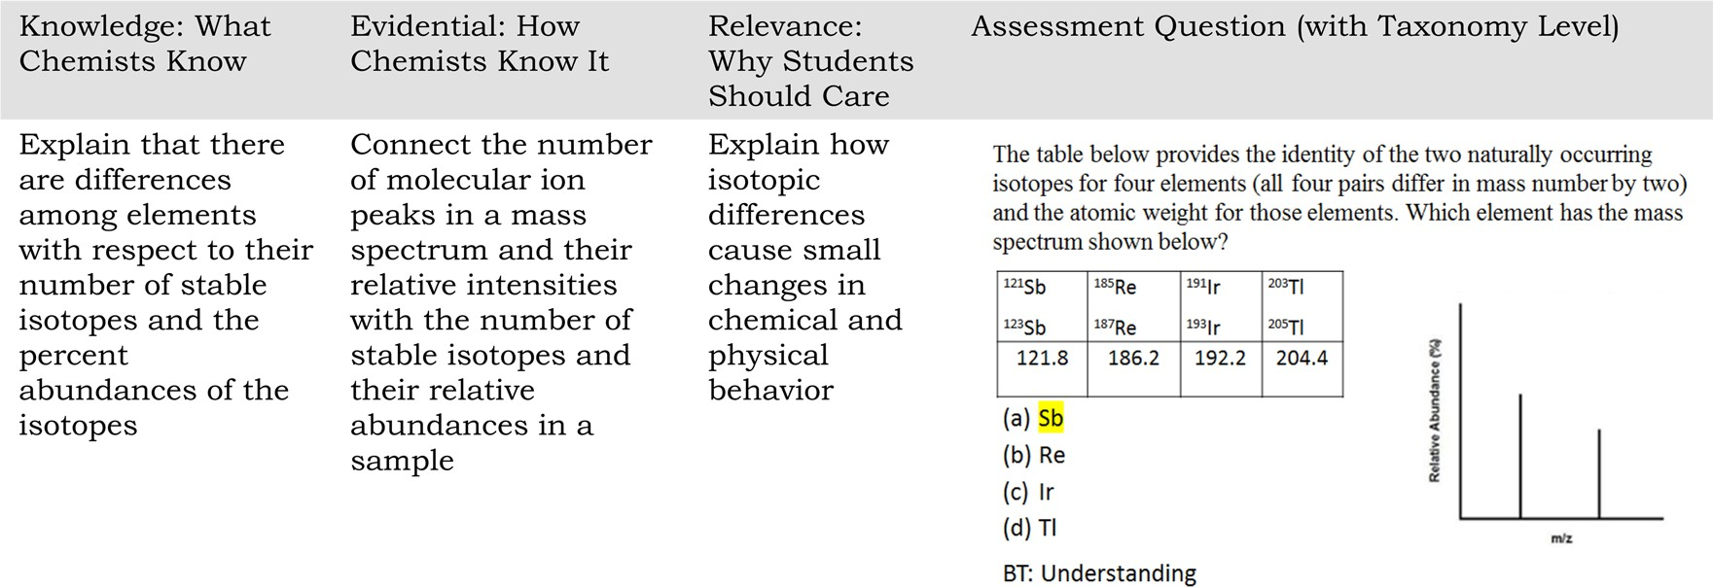

and “Your Turn” questions, where students are presented with speed bumps through a requirement to click to see an answer.

The approach is illustrated with an example from the gases module. The overall concept question for gases is “Which atmospheric gases support life?” The ﬁrst key idea asks students to explore gases that support life directly, and others that support life by regulating the energy balance of our planet. The next ﬁve key ideas cover the following: (i) the properties of gases, focusing on those physical properties that are common to all gases and

introducing the kinetic molecular theory, (ii) the temperature of the atmosphere, (iii) electromagnetic radiation and its interaction with gases, which emphasizes some of the ways gases are diﬀerent from each other, (iv) greenhouse gases, and (v) the eﬀect of greenhouse gases on our changing climate. Using eﬀective practices for visualizations,49 rather than presenting information statically, each module makes extensive use of applets or digital learning tools that invite students to interrogate data or models and explore questions about the key ideas.

In the gases module students interact with learning tools that work through fundamental ideas about the following: (i) earth’s atmosphere and temperature proﬁle, (ii) the electromagnetic spectrum, (iii) the eﬀect of electromagnetic radiation in diﬀerent regions of the spectrum on molecular substances, (iv) molecular- level mechanisms by which greenhouse gases cause tropospheric warming, and (iv) the relationship between laboratory infrared spectra and global warming potentials for greenhouse gases.

A screen capture from the learning tool depicting how the infrared spectrum of greenhouse gases plays a role in student understanding of the concept of global warming potential is shown in Figure 3. Students are guided to an understanding of the relevance of considering the IR spectrum of a greenhouse gas relative to earth’s blackbody curve and the spectral windows where carbon dioxide and water vapor do not absorb IR.

The interactive electronic materials for students were all created by the research team at the King’s Centre for Visuali- zation in Science, with an interdisciplinary group of under- graduate student researchers playing a central role in the creation of interactive resources for use by other students.65

Step 6. Assess Learning Gains by Students Piloting the

Use of VC3 Materials. Items were written for each module that aligned with the tripartite learning outcomes to assess climate science and chemistry knowledge. The items were discussed and revised within the VC3 team, which ensured validation. The items formed an instrument for each module which was administered to students as a pre-/postassessment. This allowed

for changes in student performance to be measured, and thus, impact on student learning could be measured.

The pre-/postassessment scores for each module were analyzed using the method outlined by Hake known as a normalized gain scores.66 This approach provides a method for assessing whether exposure to the VC3 modules improves student content learning, because it normalizes performances relative to prior knowledge.

A gain score can be calculated for each student that has a paired pre- and post-test score. For a class, the “gain of averages” is used and follows this formula:

<*g* > = <post‐test > −<pretest>

100 − <pretest>

The average of the pretest and post-test scores is calculated, and then the normalized gain of these averages. It is also possible to combine multiple classes that implemented a module to calculate a gain of averages across the lifetime of the project. Additionally, the chemistry items and the climate science items on each instrument can be grouped together and analyzed separately using the gain of averages method.

Within this assessment scheme, the results of several iterations of the use of the various modules are summarized in Table 2. Results are reported separately related to chemistry (Chem), climate change (CC), and overall for each module. Considering the data presented here, an overall level of gain is present in the

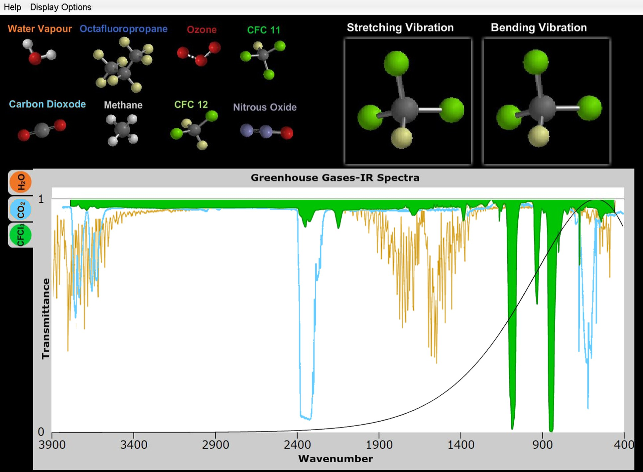

Figure 3. Screen capture of the infrared windows learning tool that guides students to an understanding of how the global warming potential of a greenhouse gas such as CFC-11 can be understood in part by its infrared spectrum. Here the IR spectrum for CFC-11 is superimposed on the laboratory IR spectra of carbon dioxide and water vapor and earth’s blackbody curve. (See ref 65.)

Table 2. Summary of Assessment Results from Pilot Implementation of VC3Modules

|  |  |  |  |
| --- | --- | --- | --- |
| Score Gain (Number of Items) | | | |
| Module (Participants) | Chemistry Items | Climate Items | Overall |
| Gases (*N* = 138 at 8 schools) | 0.23 (7) | −0.03 (3) | 0.15 |
| Isotopes (*N* = 118 at 8 schools) | 0.38 (6) | 0.45 (3) | 0.41 |
| Acids−Bases (*N* = 172 at 5 schools) | 0.07 (7) | 0.87 (2) | 0.13 |
| Thermochemistry (*N* = 52 at 2 schools) | 0.53 (7) | 0.34 (3) | 0.50 |

assessments to suggest student learning has occurred. At the same time, the learning gains are somewhat uneven, as the gains related to climate change in the gases module, for example, are roughly zero, or slightly negative. Convenience sampling also plays a role in these observations, as the schools that participate early in an implementation will have instructors who are interested in the subject, and thus have students who may be better prepared than most students at that level of course. Better early scores will result in smaller gains. Similarly, the gains in chemistry knowledge for students who used the acid/base module are quite low. In each case these results may point to established content challenges that are connected to relatively entrenched student alternate conceptions,7,10,67 and the rela- tively low gain scores in these aspects of the assessment may indicate that more in-depth interventions are needed to promote student learning for these challenging concepts.

Step 7. Disseminate Materials and Approaches and

Apply to New Rich Contexts. In response to urgent calls to engage educators as well as researchers in the areas of energy, green chemistry and processing, and environment with the importance of sustainability education related to chemistry,13,68 the VC3 approach and resources are being disseminated to both the scientiﬁc69 and science education communities.

■

students. The iterative process of creating these tripartite learning outcomes led to interesting discussions in the research team about chemistry content knowledge that is often conven- tionally presented as “inert”, without guiding students to an understanding of where that knowledge has come from and why it is relevant to learn it. The formal articulation of tripartite learning outcomes may have some value in informing perpetual discussions about “what should be left out” in general chemistry, as room is made for modern concepts and approaches, nature of science considerations, and important societal contexts related to chemistry. Heightened attention should be given to these aspects as U.S. students come into general chemistry over time having experienced a high school curriculum based on the Next Generation Science Standards. If Whitehead’s two educational commandments were to be applied to general chemistry: “Do not teach too many subjects”, and “What you teach, teach thoroughly”,3 some topics might be pruned from a course if it proved diﬃcult to meaningfully articulate sound reasons why students should ﬁnd these topics relevant in their worlds.

Additional aspects of this project are the subject of a separate

report, describing a two-tiered climate science diagnostic instrument to identify a student’s alternative conceptions about the chemistry underlying global climate change.45 Work is in progress to report details for each module about the results of chemistry content and climate literacy mapping, the tripartite learning outcomes, and key ideas for each module, along with a further assessment of learning gains by students who piloted the modules over several years.

Finally, while we did not build into the research design an assessment of aﬀective domain gains by students, the suggestions in the literature6,15,71 that students ﬁnd context-based approaches more interesting and motivating are consistent with observations made by VC3 piloting faculty and students.

■

# CONCLUSIONS, IMPLICATIONS, AND LIMITATIONS

This paper sets out a rationale, theoretical framework, and some empirical evidence for “teaching from rich contexts” as one strategy to employ in postsecondary general chemistry courses to address long-standing pedagogical challenges. A set of particularly relevant sustainability-rich contexts related to climate science were chosen because of the importance of the context as a socio-economic issue and the strong conceptual link to principles of climate literacy and general chemistry concepts. Furthermore, addressing complexity is itself an important and sometimes undervalued learning objective for required postsecondary science courses. Our approach toward developing interactive electronic resources to teach four topics in general chemistry (after mapping the rich context to chemistry content, identifying alternative conceptions related to both the context and content, and then articulating tripartite learning outcomes) has been imple- mented with considerable involvement by an undergraduate student research team. The potential of the VC3 approach to serve as an exemplar for infusing green chemistry concepts into core general and organic chemistry courses was tested with favorable responses in an ACS Green Chemistry Institute workshop70 by a group of educators from research intensive universities, PUIs, and community colleges.

A novel feature of this work was the articulation of tripartite

learning outcomes for each chemistry and climate concept, with each knowledge outcome accompanied by an outcome describing the evidential basis for that knowledge and an outcome highlighting the relevance of that knowledge for

# ASSOCIATED CONTENT

*S Supporting Information

The Supporting Information is available on the [ACS Publications](http://pubs.acs.org/) [website](http://pubs.acs.org/)at DOI: [10.1021/acs.jchemed.6b01009](http://pubs.acs.org/doi/abs/10.1021/acs.jchemed.6b01009).

Interactive electronic version of the map of climate literacy principles to core topics in general chemistry ([ZIP](http://pubs.acs.org/doi/suppl/10.1021/acs.jchemed.6b01009/suppl_file/ed6b01009_si_001.zip))

# AUTHOR INFORMATION

Corresponding Author

*E-mail: [peter.mahaﬀy@kingsu.ca](mailto:peter.mahaffy@kingsu.ca).

ORCID 

Peter G. Mahaﬀy: [0000-0002-0650-7414](http://orcid.org/0000-0002-0650-7414) Thomas A. Holme: [0000-0003-0590-5848](http://orcid.org/0000-0003-0590-5848) Marcy Towns: [0000-0002-8422-4874](http://orcid.org/0000-0002-8422-4874)

Notes

Any opinions, ﬁndings, and conclusions or recommendations expressed in this material are those of the authors and do not necessarily reﬂect the views of the National Science Foundation. The authors declare no competing ﬁnancial interest.

The complete set of interactive electronic resources is available at [www.vc3chem.com](http://www.vc3chem.com/).

■

# ACKNOWLEDGMENTS

This work was supported by the National Science Founda- tion under Grant 1022992. The VC3Chem learning materials and simulations were created by the undergraduate student

research team at the King’s Centre for Visualization of Science ([www.kcvs.ca](http://www.kcvs.ca/)). We are grateful to the faculty and students at eight North American institutions for piloting VC3 resources and providing helpful feedback and assessment data.

# REFERENCES

1. Johnson, F. Why Next Generation Science Standards. Next

Generation Science StandardsFor States, By States. [http://www.](http://www.nextgenscience.org/) [nextgenscience.org/](http://www.nextgenscience.org/) (accessed Apr 2017).

1. Johnson, F. The Case for Next Generation Science Standards. Next Generation Science StandardsFor States, By States. [http://www.](http://www.nextgenscience.org/case-next-generation-science-standards) [nextgenscience.org/case-next-generation-science-standards](http://www.nextgenscience.org/case-next-generation-science-standards) (accessed Apr 2017).
2. Whitehead, A. N. The Aims of Education. *Daedalus* 1959, *88*, 192−

205.

1. Johnstone, A. H. You Can’t Get There from Here. *J. Chem. Educ.*

2010, *87*, 22−29.

1. Gilbert, J. K. On the Nature of ″Context″ in Chemical Education.

*International Journal of Science Education* 2006, *28*, 957−976.

1. Mahaﬀy, P. G. Chemistry Education and Human Activity. In

*Chemistry Education: Best Practices, Innovative Strategies and New Technologies*; Garcia-Martinez, J., Serrano, E., Eds.; Wiley VCH: Weinheim, 2015; pp 3−26.

1. Cooper, M. The Case for Reform of the Undergraduate General Chemistry Curriculum. *J. Chem. Educ.* 2010, *87*, 231−232.
2. Kelly, R. M.; Jones, L. L. Investigating Students’ Ability To Transfer

Ideas Learned from Molecular Animations of the Dissolution Process. *J. Chem. Educ.* 2008, *85*, 303.

1. Teichert, M. A.; Tien, L. T.; Anthony, S.; Rickey, D. Effects of Context on Students’ Molecular-Level Ideas. *International Journal of Science Education* 2008, *30* (8), 1095.
2. Luxford, C. J.; Holme, T. A. What Do Conceptual Holes in Assessment Say about the Topics We Teach in General Chemistry? *J. Chem. Educ.* 2015, *92*, 993−1002.
3. Royal Society of Chemistry. Chemistry for Tomorrow’s World: A

Roadmap for the Chemical Sciences, 2009. [http://www.rsc.org/](http://www.rsc.org/globalassets/04-campaigning-outreach/tackling-the-worlds-challenges/roadmap.pdf) [globalassets/04-campaigning-outreach/tackling-the-worlds-challenges/](http://www.rsc.org/globalassets/04-campaigning-outreach/tackling-the-worlds-challenges/roadmap.pdf) [roadmap.pdf](http://www.rsc.org/globalassets/04-campaigning-outreach/tackling-the-worlds-challenges/roadmap.pdf) (accessed Apr 2017).

1. Committee on Challenges for the Chemical Sciences in the 21st Century, Board on Chemical Sciences and Technology, National Research Council of the National Academies. *Beyond the Molecular Frontier: Challenges for Chemistry and Chemical Engineering*; National Academies Press: Washington, DC, 2003.
2. Matlin, S. A.; Mehta, G.; Hopf, H.; Krief, A. One-World Chemistry and Systems Thinking. *Nat. Chem.* 2016, *8*, 393−398.
3. Talanquer, V.; Sevian, H. Chemistry in Past and New Science Frameworks and Standards: Gains, Losses, and Missed Opportunities. *J. Chem. Educ.* 2014, *91*, 24−29.
4. Parchmann, I.; Broman, K.; Busker, M.; Rudnik, J. Context-Based

Teaching and Learning on School and University Level. In *Chemistry Education: Best Practices, Innovative Strategies, and New Technologies*; Garcia-Martinez, J., Serrano, E., Eds.; Wiley-VCH: Weinheim, 2015; pp 259−278.

1. Nentwig, P. M.; Demuth, R.; Parchmann, I.; Ralle, B.; Grassel, C.

*Chemie im Kontext:* Situating Learning in Relevant Contexts While Systematically Developing Basic Chemical Concepts. *J. Chem. Educ.* 2007, *84*, 1439.

1. Bodner, G. M. Constructivism: A Theory of Knowledge. *J. Chem. Educ.* 1986, *63*, 873.
2. Bodner, G.; Klobuchar, M.; Geelan, D. The Many Forms of Constructivism. *J. Chem. Educ.* 2001, *78*, 1107.
3. Greeno, J. G. The Situativity of Knowing, Learning and Research.

*Am. Psychol.* 1998, *53*, 5.

1. Mahaffy, P. G. Moving Chemistry Education into 3D: A Tetrahedral Metaphor for Understanding Chemistry. *J. Chem. Educ.* 2006, *83* (1), 49−56.
2. Overton, T. L.; Byers, B.; Seery, M. K. Context- and Problem-

Based Learning in Higher Level Chemistry Education. In *Innovative*

*Methods of Teaching and Learning Chemistry in Higher Education*; Royal Society of Chemistry: Cambridge, 2009; pp 43−59.

1. Bulte, A. M. W.; Westbroek, H. B.; de Jong, O.; Pilot, A. A

Research Approach to Designing Chemistry Education Using Authentic Practices as Contexts. *International Journal of Science Education* 2006, *28*, 1063−1086.

1. Martin, B.; Kass, H.; Brouwer, W. Authentic Science: A Diversity of Meanings. *Sci. Educ.* 1990, *74*, 541−554.
2. King, D. New Perspectives on Context-Based Chemistry

Education: Using a Dialectical Sociocultural Approach to View Teaching and Learning. *Studies in Science Education* 2012, *48*, 51−87.

1. Hodson, D. Learning Science, Learning about Science, Doing

Science: Different goals demand different learning methods. *Interna- tional Journal of Science Education* 2014, *36*, 2534−2553.

1. Menthe, J.; Parchmann, I. Getting Involved: Context-Based

Learning in Chemistry Education. In *A*ﬀ*ective Dimensions in Chemistry Education*, Kahveci, M., Orgill, M., Eds.; Springer: Heidelberg, 2015; pp 51−68.

1. Onen, A. S.; Ulusoy, F. M. Developing the Context-based

Chemistry Motivation Scale: Validity and Reliability Analysis. *Journal of Baltic Science Education* 2014, *13*, 809−820.

1. Bauer, C. F. Attitude toward Chemistry: A Semantic Differential

Instrument for Assessing Curriculum Impacts. *J. Chem. Educ.* 2008, *85*, 1440.

1. Xu, X.; Lewis, J. E. Refinement of a Chemistry Attitude Measure for College Students. *J. Chem. Educ.* 2011, *88*, 561−568.
2. Wigfield, A.; Eccles, J. S. Expectancy−Value Theory of

Achievement Motivation. *Contemporary Educational Psychology* 2000,

*25* (1), 68−81.

1. Mason, J.; Spence, M. Beyond Mere Knowledge of Mathematics:

The Importance of Knowing-to Act in the Moment. *Educational Studies in Mathematics* 1999, *38*, 135−161.

1. Ültay, N.; Çalik, M. A. Thematic Review of Studies into the

Effectiveness of Context-Based Chemistry Curricula. *J. Sci. Educ. Technol.* 2012, *21*, 686−701.

1. Steffen, W.; Richardson, K.; Rockström, J.; Cornell, S. E.; Fetzer,

I.; Bennett, E. M.; Biggs, R.; Carpenter, S. R.; de Vries, W.; de Wit, C. A.;

Folke, C.; Gerten, D.; Heinke, J.; Mace, G. M.; Persson, L. M.; Ramanathan, V.; Reyers, B.; Sörlin, S. Planetary boundaries: Guiding Human Development on a Changing Planet. *Science* 2015, *347*, 736− 747.

1. Rockstrom, J.; Steffen, W.; Noone, K.; Persson, A.; Chapin, F. S.; Lambin, E. F.; Lenton, T. M.; Scheffer, M.; Folke, C.; Schellnhuber, H. J.; Nykvist, B.; de Wit, C. A.; Hughes, T.; van der Leeuw, S.; Rodhe, H.; Sorlin, S.; Snyder, P. K.; Costanza, R.; Svedin, U.; Falkenmark, M.; Karlberg, L.; Corell, R. W.; Fabry, V. J.; Hansen, J.; Walker, B.; Liverman,

D.; Richardson, K.; Crutzen, P.; Foley, J. A. A Safe Operating Space for Humanity. *Nature* 2009, *461*, 472−475.

1. The Economist Intelligence Unit. The Cost of Inaction:

Recognising the Value at Risk from Climate Change. [http://www.](http://www.vivideconomics.com/publications/the-cost-of-inaction-recognising-the-value-at-risk-from-climate-change) [vivideconomics.com/publications/the-cost-of-inaction-recognising-](http://www.vivideconomics.com/publications/the-cost-of-inaction-recognising-the-value-at-risk-from-climate-change) [the-value-at-risk-from-climate-change](http://www.vivideconomics.com/publications/the-cost-of-inaction-recognising-the-value-at-risk-from-climate-change) (accessed Apr 2017).

1. Burke, M.; Hsiang, S. M.; Miguel, E. Global Non-linear Effect of Temperature on Economic Production. *Nature* 2015, *527*, 235−239.
2. Hsiang, S. M.; Burke, M.; Miguel, E. Quantifying the Influence of

Climate on Human Conflict. *Science* 2013, *341*, 1235367.

1. Zalasiewicz, J.; et al. The Anthropocene: A New Epoch of Geological Time? *Philos. Trans. R. Soc., A* 2011, *369*, 835−841.
2. Mahaffy, P. G. Telling Time: Chemistry Education in the Anthropocene Epoch. *J. Chem. Educ.* 2014, *91*, 463−465.
3. American College and University Presidents’ Climate Leadership

Commitments. [http://secondnature.org/what-we-do/climate-](http://secondnature.org/what-we-do/climate-leadership/) [leadership/](http://secondnature.org/what-we-do/climate-leadership/) (accessed Apr 2017).

1. Shepardson, D. P.; Niyogi, D.; Roychoudhury, A.; Hirsch, A. Conceptualizing Climate Change in the Context of a Climate System: Implications for Climate and Environmental Education. *Environmental*

*Education Research* 2012, *18*, 323−352.

1. McCaffrey, M. S.; Buhr, S. M. Clarifying Climate Confusion: Addressing Systemic Holes, Cognitive Gaps, and Misconceptions

through Climate Literacy. *Physical Geography* 2008, *29*, 512−528.

1. National Research Council. *Next Generation Science Standards:*

*For States, by States*; The National Academies Press: Washington, DC, 2013.

1. McCuin, J. L.; Hayhoe, K.; Hayhoe, D. Comparing the Effects of Traditional vs. Misconceptions-based Instruction on Student Under- standing of the Greenhouse Effect. *Journal of Geoscience Education* 2014,

*62* (3), 445−459.

1. Versprille, A.; Zabih, A.; Holme, T. A.; McKenzie, L.; Mahaffy, P.

G.; Martin, B. E.; Towns, M. Assessing Student Knowledge of Chemistry and Climate Science Concepts Associated with Climate Change: Resources To Inform Teaching and Learning. *J. Chem. Educ.*

2017, *94* (4), 407−417.

1. Grassian, V. H.; Stone, E. A. Chemistry’s Contributions to Our

Understanding of Atmospheric Science and Climate. *J. Chem. Educ.*

2015, *92*, 595−597.

1. Sterman, J. D.; Sweeney, L. B. Cloudy Skies: Assessing Public

Understanding of Global Warming. *System Dynamics Review* 2002, *18*, 207−240.

1. Hmelo-Silver, C.; Marathe, S.; Liu, L. Fish Swim, Rocks Sit, and Lungs Breathe: Expert−Novice Understanding of Complex Systems. *Journal of the Learning Sciences* 2007, *16*, 307−331.
2. Martin, B. E.; Mahaﬀy, P. G. Using Visualizations of the Science

Behind Climate Change to Change the Climate of Science Teaching. In *Pedagogic Roles of Animations and Simulations in Chemistry Courses*; Suits, J., Ed.; American Chemical Society: Washington DC, 2013; pp 411− 440.

1. Mahaﬀy, P. G.; Bucat, B.; Tasker, R.; Kotz, J.; Treichel, P.; Weaver, G.; McMurry, J. *Chemistry: Human Activity, Chemical Reactivity*, 1st Canadian ed..; Nelson Education: Toronto, 2011.
2. Brown, T. E.; LeMay, H. E.; Bursten, B. E.; Murphy, C.; Woodward, P. W. *Chemistry: The Central Science*; Pearson: New York, 2009.
3. Kotz, J. C.; Treichel, P.; Townsend, J. *Chemistry and Chemical Reactivity*; Cengage: Independence, KY, 2009.
4. Petrucci, R. H.; Herring, F. G.; Madura, J. D.; Bissonnette, C. *General Chemistry: Principles and Modern Applications*; Pearson: New York, 2010.
5. Tro, N. J. *Chemistry: A Molecular Approach*; Pearson: New York,

2011.

1. Silberberg, M. S. *Chemistry: The Molecular Nature of Matter and Change*; McGraw Hill: New York, 2008.
2. Chang, R. *Chemistry*; McGraw Hill: New York, 2010.
3. U.S. Global Change Research ProgramClimate Change Science Program. *Climate Literacy: The Essential Principles of Climate Sciences*; U.S. Global Change Research Program: Washington, DC, 2009.
4. Barke, H.; Hazari, A.; Yitbarek, S. *Misconceptions in Chemistry*;

Springer: Berlin, 2009.

1. Mulford, D. R.; Robinson, W. R. An Inventory for Alternate Conceptions among First-Semester General Chemistry Students. *J. Chem. Educ.* 2002, *79*, 739−744.
2. Kind, V. *Beyond Appearances: Students’ Misconceptions About Basic*

*Chemical Ideas*, 2nd ed.; Royal Society of Chemistry: Cambridge, 2004.

1. Taber, K. *Chemical Misconceptions*; The Royal Society of Chemistry: Cambridge, 2002.
2. Horton, C. Student Alternative Conceptions in Chemistry.

*California Journal of Science Education* 2007, *7*.

1. Versprille, A. N.; Towns, M. H. General Chemistry Students’ Understanding of Climate Change and the Chemistry Related to Climate Change. *J. Chem. Educ.* 2015, *92*, 603−609.
2. Anderson, L. W.; Krathwohl, D. R.; Bloom, B. S. *A Taxonomy for*

*Learning, Teaching, and Assessing: A Revision of Bloom’s Taxonomy of Educational Objectives*; Longman: New York, 2001.

1. King’s Centre for Visualization in Science, The King’s University,

Edmonton, Alberta. <http://www.kcvs.ca/> (accessed Apr 2017).

1. Hake, R. Interactive-Engagement Versus Traditional Methods: A Six Thousand Student Survey of Mechanics Test Data for Introductory Physics Courses. *Am. J. Phys.* 1998, *66* (1), 64−74.
2. McClary, L. M.; Bretz, S. L. Development and Assessment of a

Diagnostic Tool to Identify Organic Chemistry Students’ Alternative Conceptions Related to Acid Strength. *International Journal of Science Education* 2012, *34*, 2317.

1. Grassian, V. H.; Meyer, G.; Abruña, H.; Coates, G. W.; Achenie, L. E.; Allison, T.; Brunschwig, B.; Ferry, J.; Garcia-Garibay, M.; Gardea- Torresdey, J.; Grey, C. P.; Hutchison, J.; Li, C.; Liotta, C.; Raguskas, A.; Minteer, S.; Mueller, K.; Roberts, J.; Sadik, O.; Schmehl, R.; Schneider, W.; Selloni, A.; Stair, P.; Stewart, J.; Thorn, D.; Tyson, J.; Voelker, B.; White, J. M.; Wood-Black, F. Chemistry for a Sustainable Future.

*Environ. Sci. Technol.* 2007, *41*, 4840−4846.

1. Mahaffy, P. G.; Martin, B. E.; Kirchhoff, M.; McKenzie, L.; Holme,

T.; Versprille, A.; Towns, M. Infusing Sustainability Science Literacy through Chemistry Education: Climate Science as a Rich Context for

Learning Chemistry. *ACS Sustainable Chem. Eng.* 2014, *2*, 2488−2494.

1. Mahaﬀy, P. G.; Haack, J. *July 15, 2015 Workshop: Creating Learning Objectives that Infuse Green Chemistry and Engineering Concepts*

*into the Chemistry Curriculum*. [https://presentations.acs.org/common/](https://presentations.acs.org/common/presentation-detail.aspx/GCE2015/GCEE/GCE011a/2262534) [presentation-detail.aspx/GCE2015/GCEE/GCE011a/2262534](https://presentations.acs.org/common/presentation-detail.aspx/GCE2015/GCEE/GCE011a/2262534) (ac- cessed Apr 2017).

1. Taber, K. S. Meeting Educational Objectives in the Aﬀective and

Cognitive Domains: Personal and Social Constructivist Perspectives on Enjoyment, Motivation and Learning in Chemistry. In *A*ﬀ*ective Dimensions in Chemistry Education*; Kahveci, M., Orgill, M., Eds.; Springer: Heidelberg, 2015, pp 3−27.